Stour Row Village Hall Emergency Evacuation Procedure

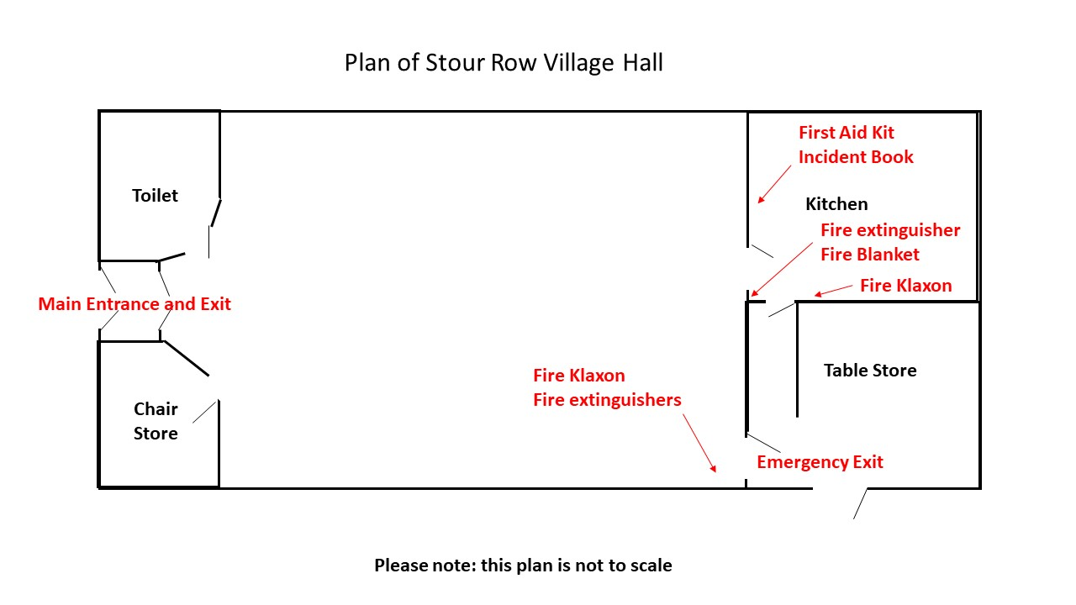
If you discover a fire, or on hearing one of the smoke detector alarms, calmly but loudly shout “Fire” (or other warning if appropriate) and press the trigger on one of the fire alarm klaxons located in hall and kitchen area (see plan of building above)
On hearing the shout of “Fire” or hearing one the klaxon fire alarms or smoke detector alarms, evacuate the building as quickly as possible. If it is possible to safely do so, close windows and doors in the immediate area. Ensure others are also evacuating the building in response to the alarm. Using the nearest safe fire exit route (see plan of building above), evacuate the building exit the hall grounds through the gate onto the road. Assemble on the pavement in College Arms Close (the road almost opposite the village hall). Take care when crossing the road.
Once clear of the building call the local fire brigade by dialling 999 and alert them to the fire. The address of the building is: The Village Hall, Stour Row, Dorset, SP7 0QF

