Stour Row Village Hall Health and Safety Policy

This document is the Health and Safety policy set out by the Stour Row Village Hall Management Committee (VHMC)

Our policy is to:

i. Provide healthy and safe working conditions, equipment and systems of work for all people visiting or using the hall.
ii. Keep the hall premises and its facilities and equipment in a safe condition for all users.
iii. Provide such training and information as is necessary to ensure all users, volunteers and visitors can safely use the hall.
The Committee consider the promotion of health and safety of all who use the premises, including contractors who may work there, to be of great importance. They recognise that the effective prevention of accidents depends as much on a committed attitude of mind to safety as on the operation and maintenance of equipment and safe systems of work. To this end, they will seek to encourage all visitors, contractors, users and volunteers to engage in the establishment and observance of safe working practices.

All contractors, visitors, volunteers and users will be expected to recognise that there is a duty on them to comply with the practices set out by the Committee, with all safety requirements set out in the hiring agreement and with safety notices on the premises and to accept responsibility to do so.

1.0 Responsibilities for Health and Safety
1.1 The Village Hall management Committee (VHMC) have overall responsibility for Health and Safety in the hall and it is the intention of the VHMC to comply with all Health and Safety legislation and to act positively where they can reasonably do so to prevent injury, ill health or any danger arising from the activities and operations in the hall.
1.2 All users of the facilities are expected to read this Health and Safety Policy statement as a condition of their hire and to recognise that it is their duty to comply with the procedures and all safety requirements, including safety notices at the site. They will be required to sign the hiring form as evidence that they agree to the hiring conditions.
1.3 It is the duty of all contractors, hirers, visitors and volunteers to:
i.) take care of themselves and others who may be affected by their activities. ii.) do everything they reasonably can to prevent injury to themselves and others.
iii.) co-operate with the VHMC in keeping the premises safe.

1.4 Should anyone using the hall come across a fault, damage or other situation which might cause injury and cannot be rectified immediately, they should inform the Chairman or Secretary as soon as possible so that the problem can be dealt with. Where equipment is damaged, a notice should be placed on it warning that it is not to be used and it should be reported immediately to the Chairman or Secretary. The contact details for the chairman and secretary of the VHMC are available in the hall (posted on the safety notice board) and on the Stour Row Community website.

1.5 Routine inspection of safety equipment is conducted by appointed Committee members or their nominees. The checks are carried out at least monthly.

2.0 Safety Information

2.1 Fire Precautions and Checks
2.1.1 A plan of the hall showing the location of fire exits, fire warning horns, fire extinguishers and fire blanket is shown in Appendix 1 and a similar plan is posted on the safety notice board
2.1.2 A copy of the hall emergency evacuation procedure is included as an attachment to this document and is also displayed on the hall safety noticeboard. In addition, representatives of all groups that uses the hall are required to sign to say that they have made themselves familiar with emergency evacuation procedure. A guide to the emergency evacuation procedures is provided to all hirers and is attached (Appendix 2).
2.1.3 Fire extinguishers are serviced annually and a record of this is shown on individual extinguishers. Alarms and smoke detectors are checked regularly.

2.2 Risk Assessments
The VHMC carry out risk assessments to assess and examine activities that could cause harm to people to help decide whether sufficient precautions are in place or whether more needs to be done to prevent harm. These risk assessments also help the Committee to comply with the various laws and regulations contained in a wide range of legislation. Full copies of the risk assessments are available from the Secretary on request. An abbreviated version can be found in appendix 3 of this document.
The risk assessments, together with the actions and outcomes they may identify, are kept under review in order to achieve the lowest level of risk possible. However, the Committee is aware that risk can never be eliminated completely. New risk assessments are carried out if new or changed circumstances are identified and are part of the Committee’s on-going commitment to safety.

3.0 Safety Practices
The following practices must be followed to minimise hazards:
• Make sure that all emergency exits doors are clear and unlocked as soon as the hall is to be used and throughout the hiring.
• Do not operate or touch any electrical equipment where there are signs of damage, exposure of components or water penetration, etc.
• Do not work on steps, ladders or at a height until that are properly secured.
• Do not leave portable electrical devices operating while unattended without the permission of the VHMC
• Do not bring onto the property any portable electrical appliances which have not been Portable Appliance Tested.
• Do not attempt to move heavy or bulky items (e.g. stacked tables or chairs) without the proper equipment.
• Do not stack chairs more than six high.
• Do not attempt to carry or tip a water boiler when it contains hot water. Leave it to cool.
• Do not allow children in the kitchen except under close supervision. Avoid overcrowding and do not allow running.
• Wear suitable protective clothing when handling cleaning or other toxic materials.
• All faults or repairs should be noted in the maintenance manual kept in kitchen next to the first aid kit. In addition, all faults that could be dangerous should be brought to the attention of the Chairman or Secretary of the VHMC (see safety notice board for contact details). If these individuals cannot be contacted, please inform any member of the management committee.

• Report every accident in the incident book and also to the Secretary or Chairman of the VHMC (see safety notice board for contact details)
• Be especially aware and take great care to avoid the following risks:
*Creating slipping hazards on steps or wet floors – mop spills immediately.
*Creating tripping hazards items such as buggies, umbrellas, bags, mops and other items should put away or left in safe locations.
*Avoiding trip hazards by using adequate lighting.
*Risk to individuals while in sole occupancy of the building.
*Risks involved in handling kitchen equipment e.g. cooker, water heater and knives.
*Creating toppling hazards by piling equipment e.g. in store rooms.

4.In Case of Accidents
4.1 The nearest 24 hour Accident and Emergency/Casualty dept. is:
Higher Kingston, Yeovil, Somerset, BA21 4AT Tel: 01935 475122

There is a minor injuries unit at the Westminster Memorial Hospital operating from 8.00am to 8.00pm daily (Abbey Walk, Shaftesbury, Dorset, SP7 8BD (Tel: 01747 851535)

4.2 The nearest doctor’s surgery is: The Blackmore Vale Partnership, Abbey View Medical Centre , Shaftesbury, Dorset, SP7 8DH (Tel01747 856700)
4.3 The First Aid Box is located in the kitchen.
4.4 The Incident book is kept in kitchen area along with the first aid kit. This must be completed whenever an dangerous or potentially dangerous incident occurs. All accidents, even minor ones, must be reported to the Secretary in addition in, the case of major injuries, a RIDDOR report should be filed. major (https://www.hse.gov.uk/riddor/index.htm)

5.0 Insurance
A copy of the Employer’s Liability and Public Liability Insurance certificate for the hall and is displayed on the hall safety noticeboard and can also be obtained from the Treasurer upon request (contact details available on the Stour Row Community website, https://stourrowvillage.org/)

6.0 Contractors
Before any contractor or person on site begins any works they should:
a) Carry out their own risk assessment
b) Ensure they have adequate liability cover
c) Familiarise themselves with this Health and Safety Policy.

General Mitigation of Risk
To mitigate risk of fire, smoking and naked flames are banned through-out the Stour Row Village Hall.
It is a condition of hire of the Hall that the responsible person makes themselves aware of the location of the fire exits, fire extinguishers and fire alarms as wells the fire evacuation procedure. This information must be relayed to all the people present.
No portable gas supplies can be used in the building.
All Incidents that cause injury or have the potential to cause injury must be reported in the Incident Book.
The contact details for accident and emergency services, the local GPs surgery and the local accident and local minor injuries department are displayed prominently near the first aid kit in the kitchen.
Signs clearly indicate the location of the first aid kit in the kitchen area.

7.0 Review of Health and Safety Policy
The Committee will review this policy regularly and as required by any change of circumstances.

Appendix 1
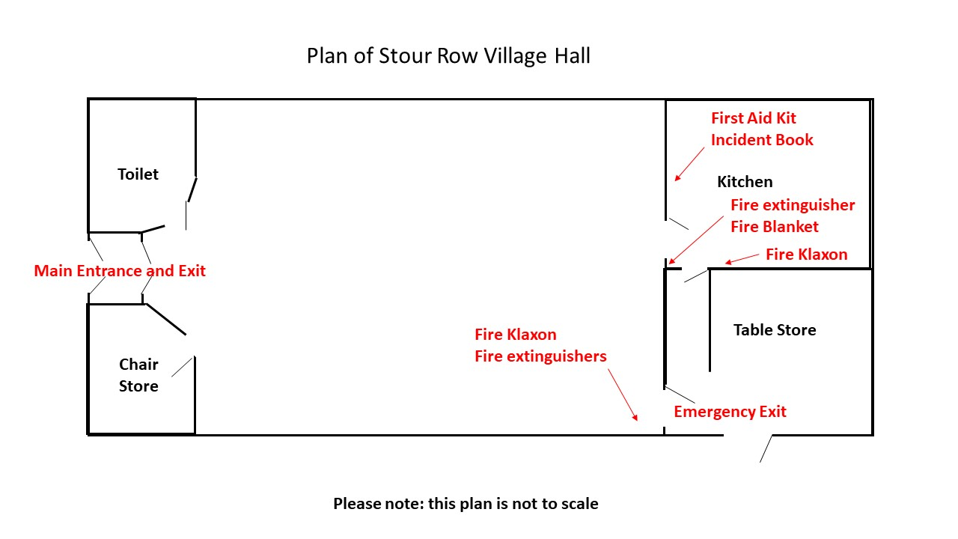
Appendix 2

Stour Row Village Hall Emmergency Evacuation Procedure
If you discover a fire, or on hearing one of the smoke detector alarms, calmly but loudly shout “Fire” (or other warning if appropriate) and press the trigger on one of the fire alarm klaxons located in hall and kitchen area (see Appendix 1).
On hearing the shout of “Fire” or hearing one the klaxon fire alarms or smoke detector alarms, evacuate the building as quickly as possible. If it is possible to safely do so, close windows and doors in the immediate area. Ensure others are also evacuating the building in response to the alarm. Using the nearest safe fire exit route (see Appendix 1), evacuate the building exit the hall grounds through the gate onto the road. Assemble on the pavement in College Arms Close (the road almost opposite the village hall). Take care when crossing the road.
Once clear of the building call the local fire brigade by dialling 999 and alert them to the fire. The address of the building is: The Village Hall, Stour Row, Dorset, SP7 0QF

Use of Fire extinguishers
Fire extinguishers should only be used on small, contained fires (e.g. within a bin). Do not use the fire extinguishers unless you know the correct sort of extinguisher for the type of fire. It is much more important that everybody clears the building as soon as possible and calls the fire brigade. Do not place yourself at risk by trying to contain a blaze.
Never try to fight a blaze with an extinguisher if:
- The fire is too large
- High levels of smoke in the air
- The environment is too hot or smoky
- Evacuation paths are impaired
- If an extinguisher is used for any reason, it must be noted in the Incident Book and Booking Secretary must be informed.

Appendix 3 – Abbreviated list of risk assessments for users of the Stour Row Village Hall

Risk How to mitigate the risk
Fire | Ensure all users are aware of the location fire exits, fire equipment and fire evacuation protocols.  Ensure only equipment with a current PAT test is used.  Ensure bins are regularly emptied and kitchen area is kept tidy.  Fire equipment should be regularly checked and service in line with the manufacturer’s recommendations.
Electric Shock | Ensure that electrical equipment is only used by adults and that these individuals are aware of the dangers of electrical shock.  Ensure only portable equipment with a current PAT test is used.
Falls/Trips/Slips | Ensure that all areas of the hall are kept tidy.  Ensure that any liquid spilt or found on the floor is mopped up as soon as possible.  Take extreme care if standing on something above floor level.
Risk in the Kitchen | The kitchen area should never be overcrowded particularly when hot food or drinks are being prepared.  Children should be kept out of the kitchen area when hot food or drink is being prepared.  Any spills should be cleaned up as soon as possible.  Do not attempt to carry or tip a water boiler when it contains hot water. Leave it to cool.
Risk of exposure to chemicals | No chemicals other than commercially available cleaning products should be brough into the village hall.  Accidental exposure to a toxic chemical should be treated as recommended by the manufacturer.  There is list of local medical services by the first aid kit in the kitchen area.

